- Theme: light + (default light)
1. Introduction

- Shell scripts are interpreted not compiled
- To see installed shells in your machine
  - cat /etc/shells
- sh is borne shell….still used in unix system, the first shell which was used
- bash ...born again shell…. Standard gnu which is intutive and flexible
- to see where bash is located
  - which bash
- #! shebang/hashbang

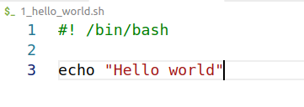

2. Using Variables and Comments

- Two types of variables
  - system variable (Capital case)
  - user defined variables
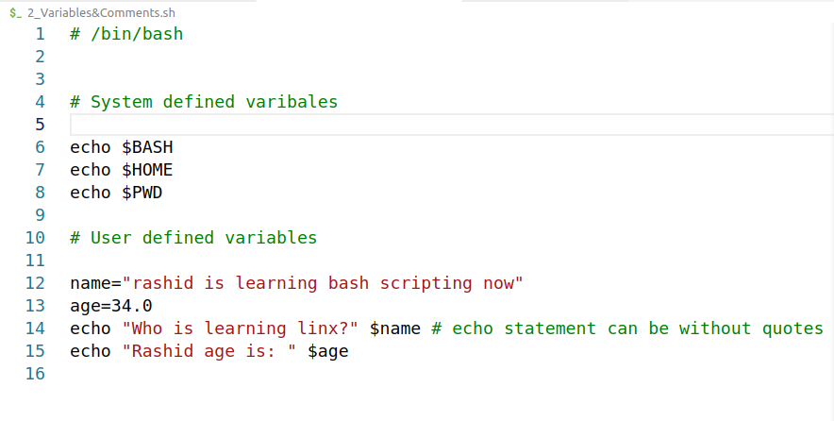

3. Read User Input

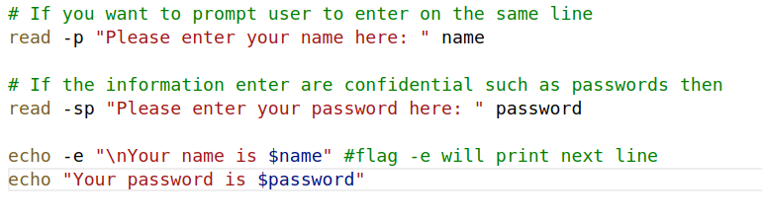
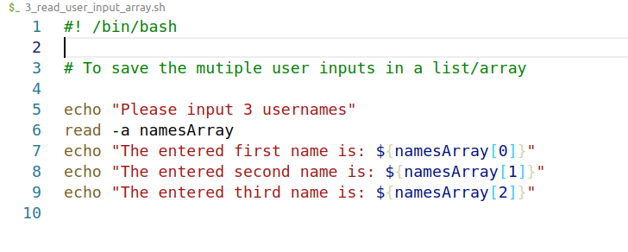
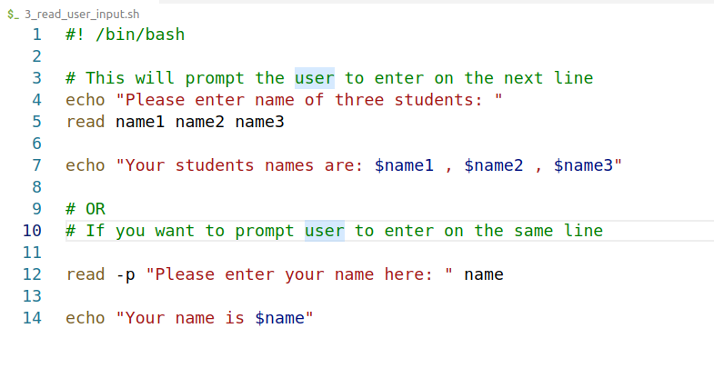

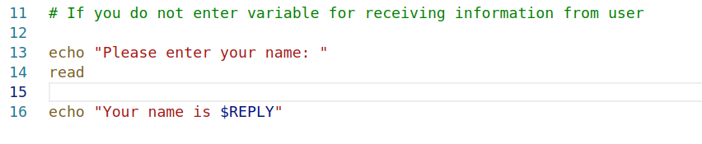

4. Pass Arguments to a Bash Scripting

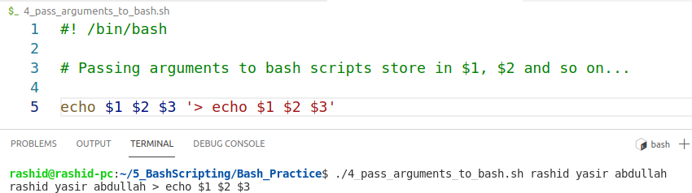
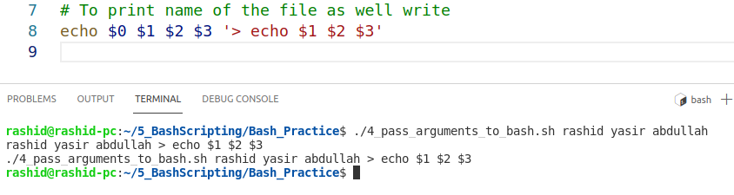

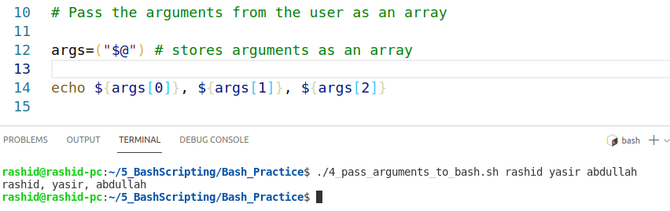
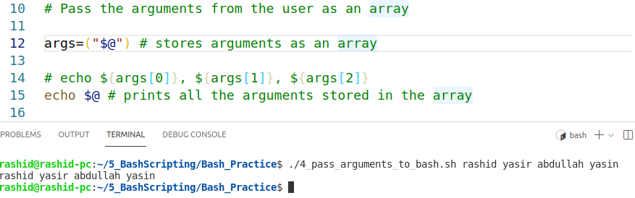

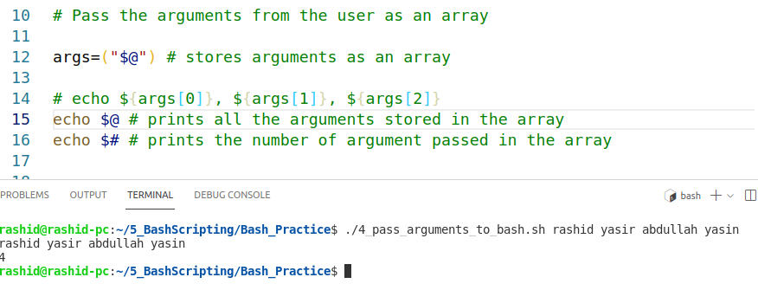

5. Conditional Statements

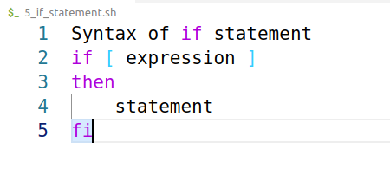

Comparison Operators

Integer Comparison
-eq is equal to if [ "$a" -eq "$b" ]
-ne is not equal to if [ "$a" -ne "$b" ]
-gt is greater than if [ "$a" -gt "$b" ]
-ge is greater than or equal to if [ "$a" -ge "$b" ]
-lt is less than if [ "$a" -lt "$b" ]
-le is less than or equal to if [ "$a" -le "$b" ]
< is less than (within double parentheses) (("$a" < "$b"))
<= is less than or equal to (within double parentheses) (("$a" <= "$b"))
> is greater than (within double parentheses) (("$a" > "$b"))
>= is greater than or equal to (within double parentheses) (("$a" >= "$b"))

String Comparison
= is equal to if [ "$a" = "$b" ]
Note the whitespace framing the =.
if [ "$a"="$b" ] is not equivalent to the above.
== is equal to if [ "$a" == "$b" ]
This is a synonym for =.
The == comparison operator behaves differently within a double-brackets test than within single brackets.
[[ $a == z* ]] # True if $a starts with an "z" (pattern matching).
[[ $a == "z*" ]] # True if $a is equal to z* (literal matching).

[ $a == z* ] # File globbing and word splitting take place.
[ "$a" == "z*" ] # True if $a is equal to z* (literal matching).

# Thanks, Stéphane Chazelas

!= is not equal to if [ "$a" != "$b" ]
This operator uses pattern matching within a [[ ... ]] construct.
< is less than, in ASCII alphabetical order
if [[ "$a" < "$b" ]]
if [ "$a" \< "$b" ]
Note that the "<" needs to be escaped within a [ ] construct.
> is greater than, in ASCII alphabetical order
if [[ "$a" > "$b" ]]
if [ "$a" \> "$b" ]
Note that the ">" needs to be escaped within a [ ] construct.
See Example 27-11 for an application of this comparison operator.
-z string is null, that is, has zero length
String='' # Zero-length ("null") string variable.

if [ -z "$String" ]
then
echo "\$String is null."
else
echo "\$String is NOT null."
fi # $String is null.

-n string is not null.
The -n test requires that the string be quoted within the test brackets. Using an unquoted string with ! -z, or even just the unquoted string alone within test brackets (see Example 7-6) normally works, however, this is an unsafe practice. Always quote a tested string.

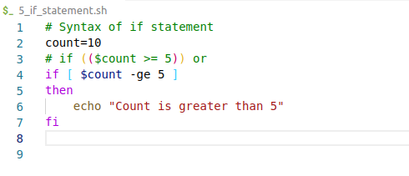
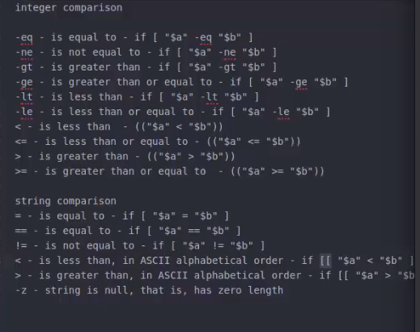

OR
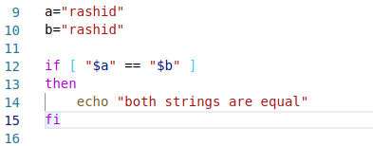

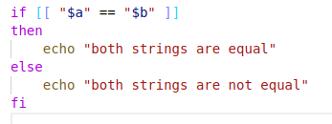

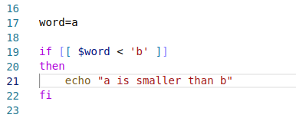

- use double brackets when you are using angle brackets (>,<) i.e., (( )) in case of comparing integers, and [[]] in case of comparing strings
- Convention that I will follow….
  - For strings, always use [[ ]] with comparison operators like ==, > etc
  - for integers, always use [] and use urinary operator like -eq, -gt etc.

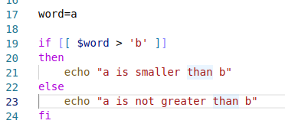

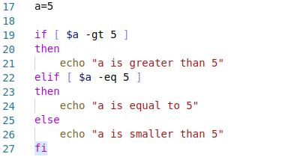

6. File Test Operators

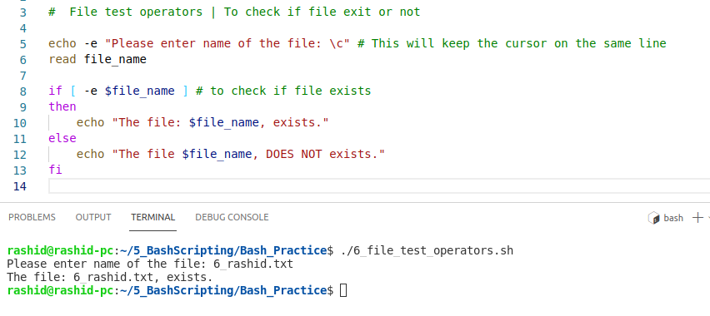
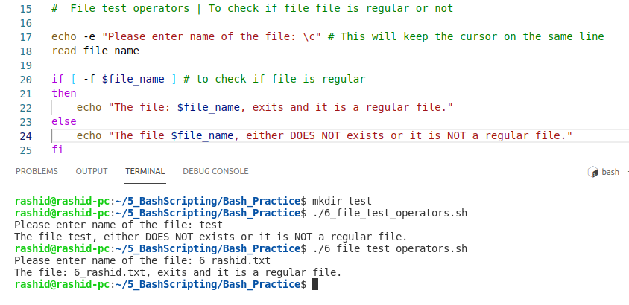
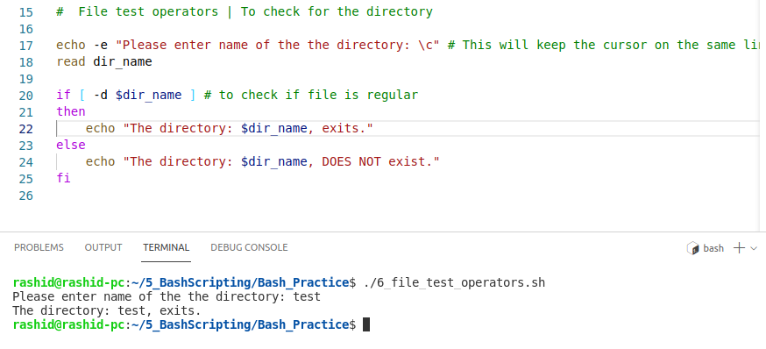

- Two types of files
  - character special file: normal file (-b)
  - block special file: binary file (-c)
- To check whether file is empty or not (-s)
- To check whether file has read, write, executable permission (-r, -w, -x)

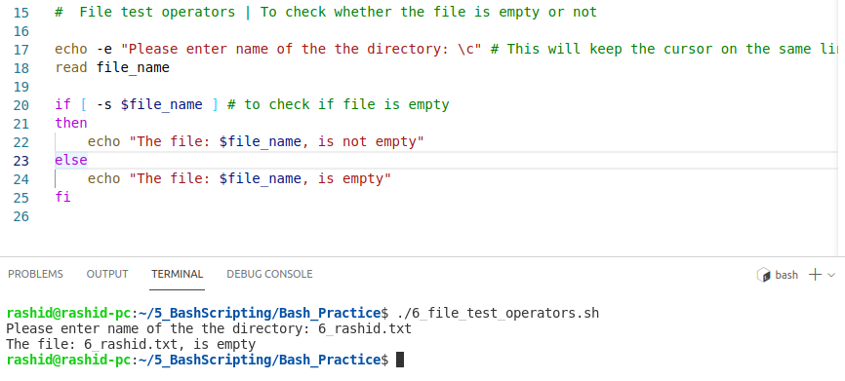

7. How to append output of the end of the file
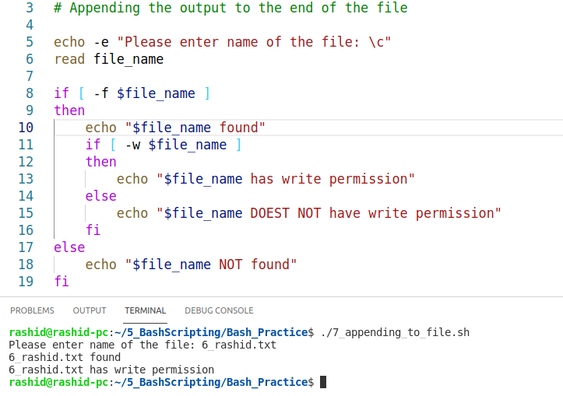
- cat > : will over-write the file
- cat >> : will append the data at the end of the file
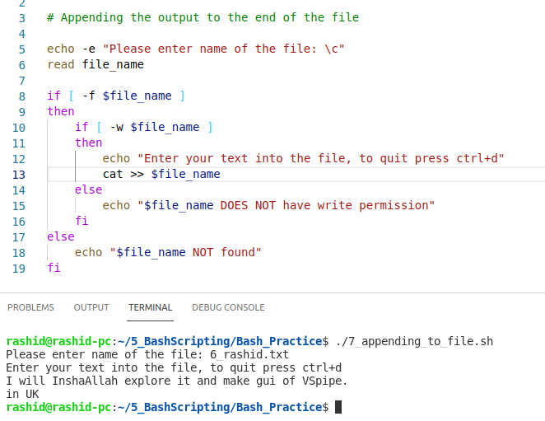
8. Logical ‘AND’ Operator
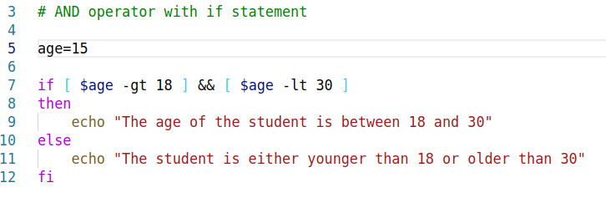
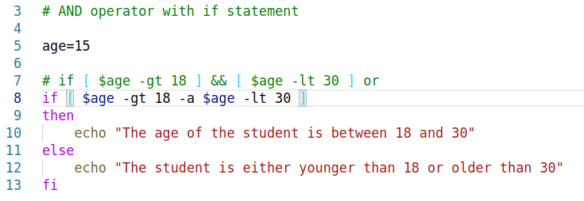

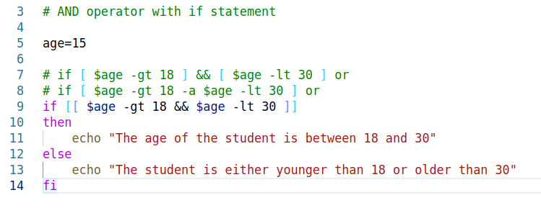

9. Logical ‘OR’ Operator

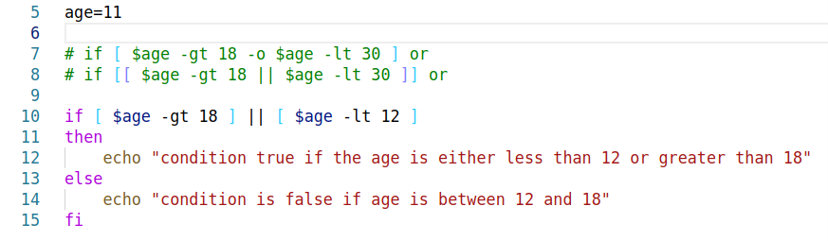

10. Perform Arithmetic Operations

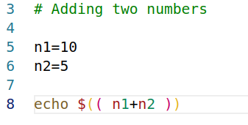

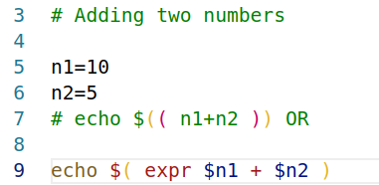

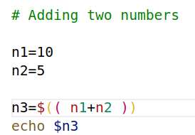

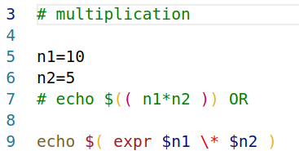

11. Floating point math operations in bash | bc command

- echo "10.5+5" | bc
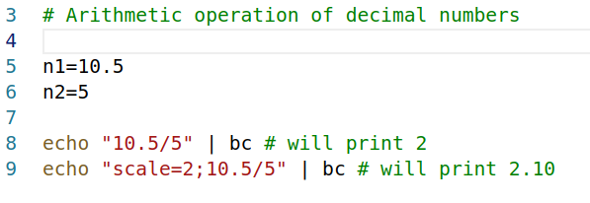
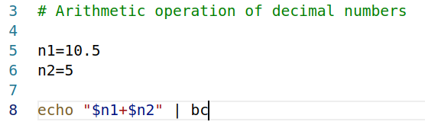

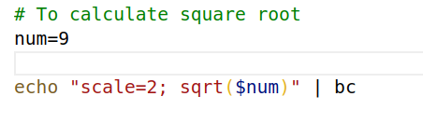

- echo "scale=2; 3^3" | bc

12. The Case Statement / 13. The Case Statement Examples
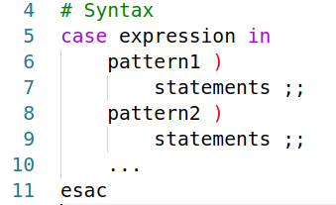

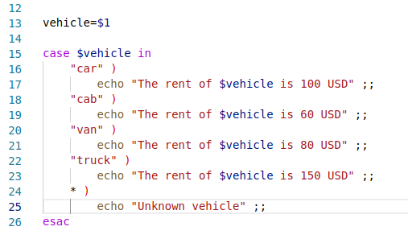

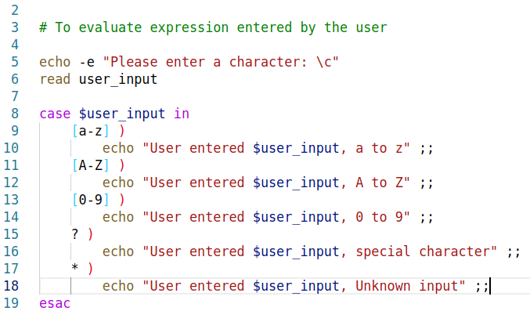
14. Array Variables

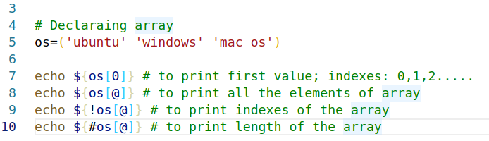
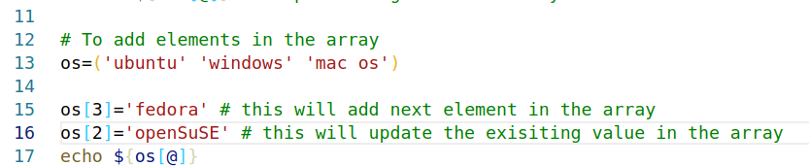
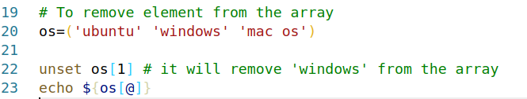

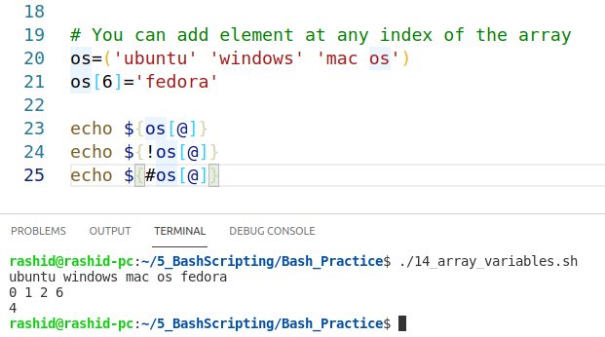
- Above code means that some indexes in the array may be left UN-initialized and gaps in the array are OK.
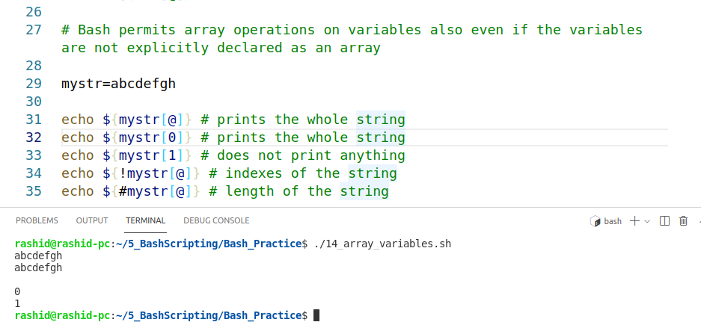

15. WHILE Loops

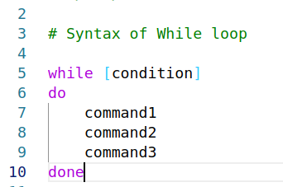

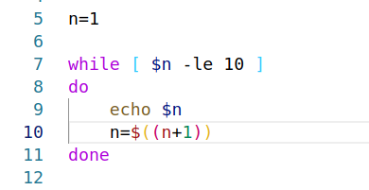

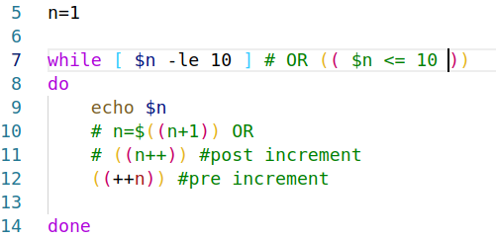

16. Using sleep and open terminal with WHILE Loops
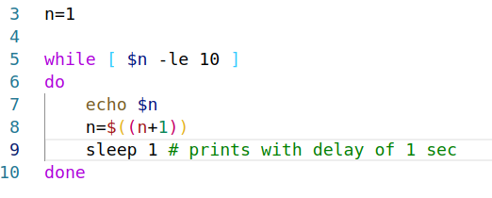

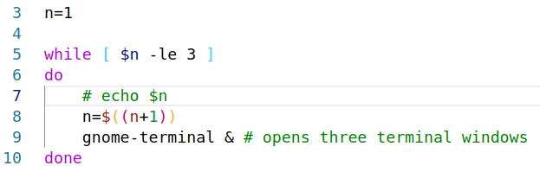
17. Read a file content in bash
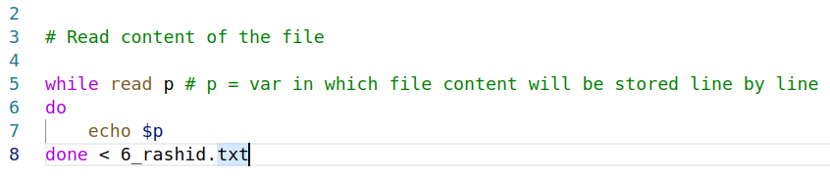
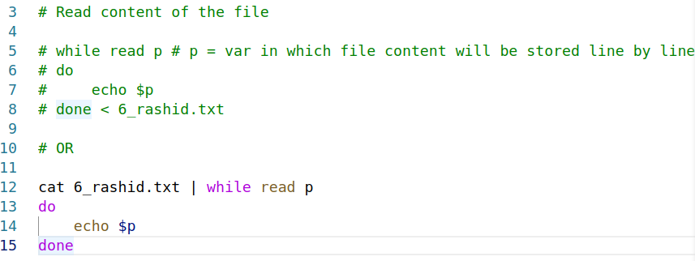

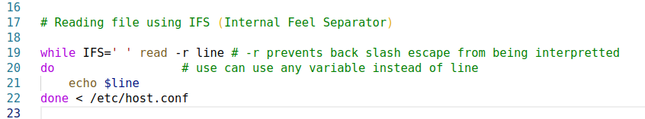
18. UNTIL loop

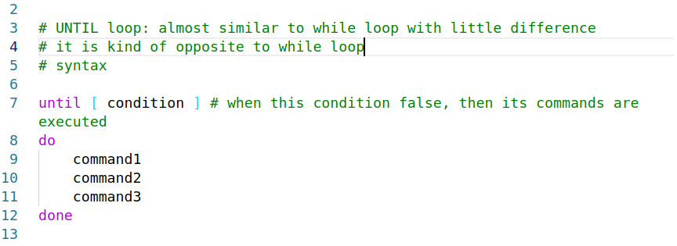
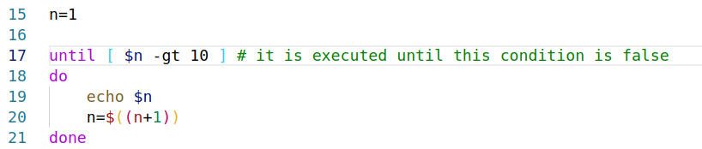

19. FOR loop

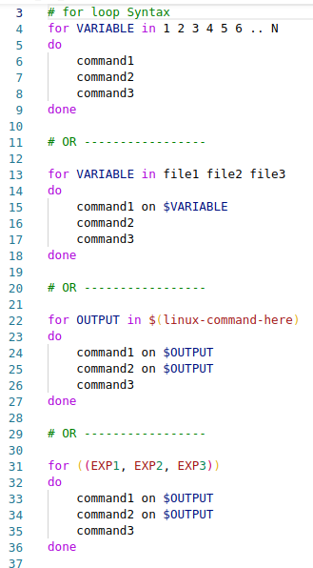

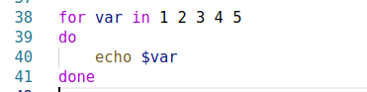

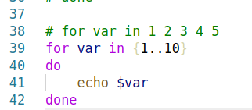

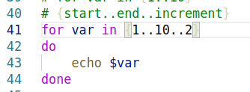

- echo ${BASH_VERSION}
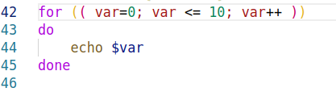

20. FOR loop to execute commands

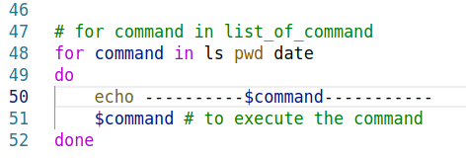

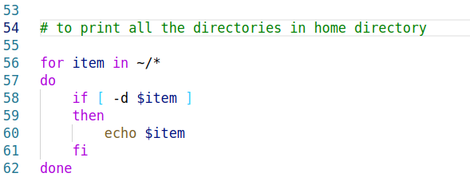

21. Select Loop
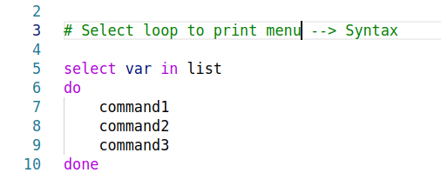

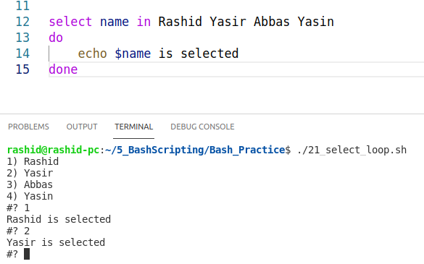

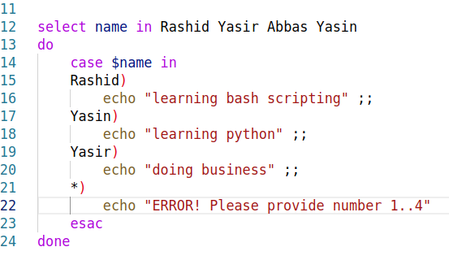

22. Break and continue statement

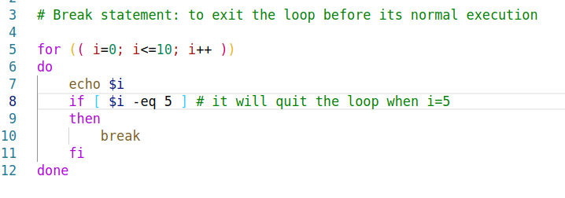
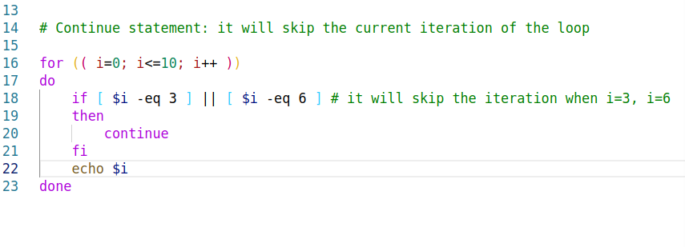

23. Functions

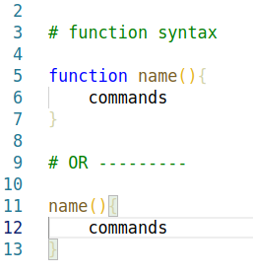

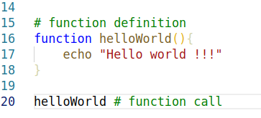

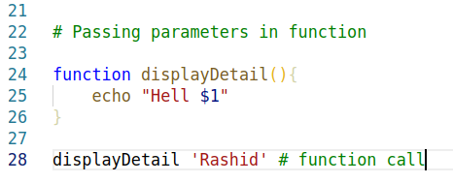

24. Local Variables

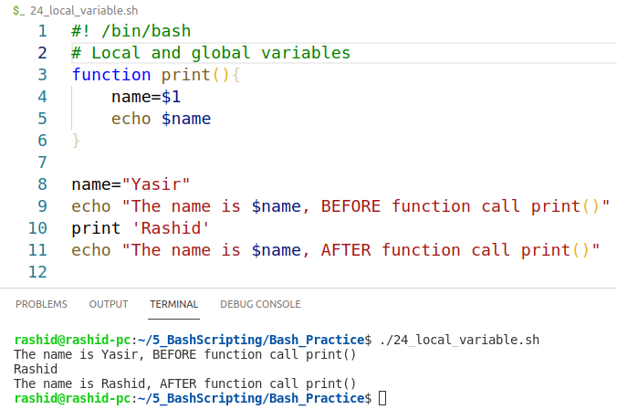
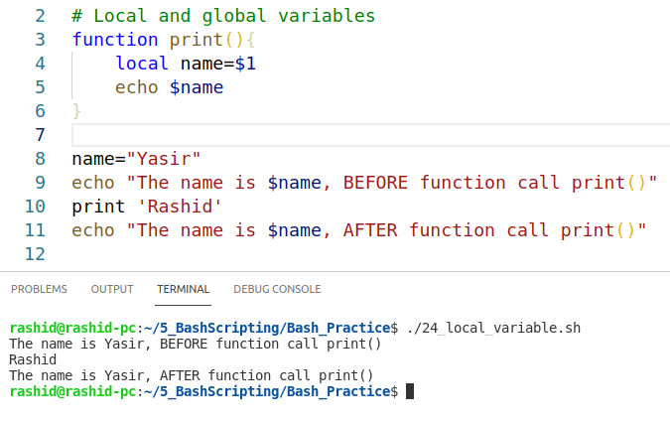
25. Function Examples

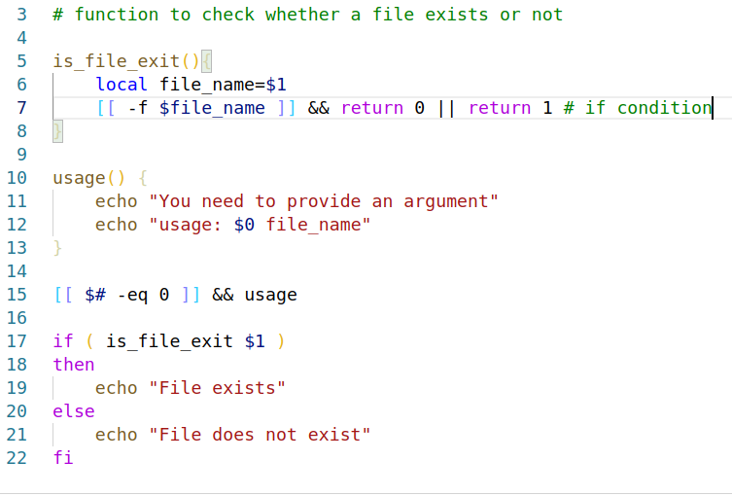
26. Read only command

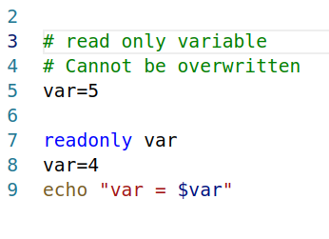

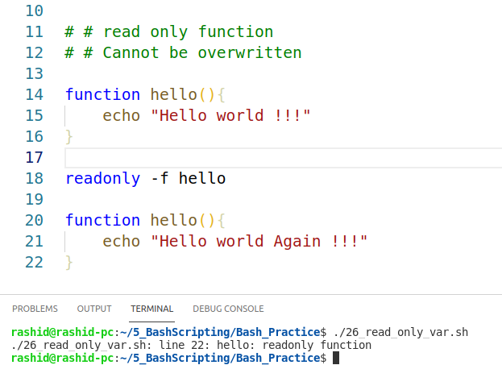
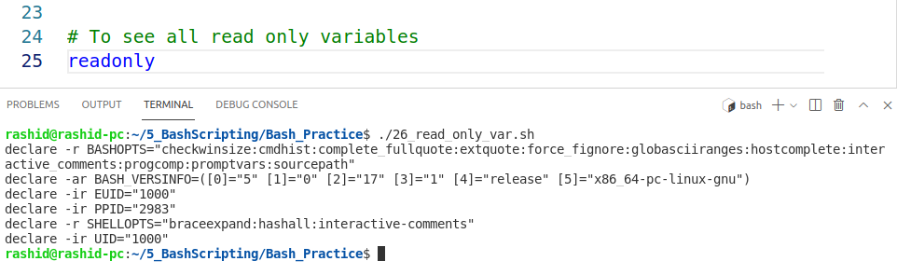
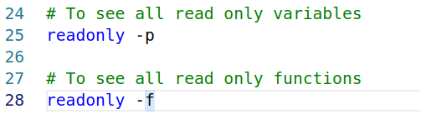

27. Signals & Trap

- To kill the process
  - kill -9 pid
- '$$' to print pid of the script itself
- to check about different signals
- man 7 signal
- simicolon is used to combine two commands
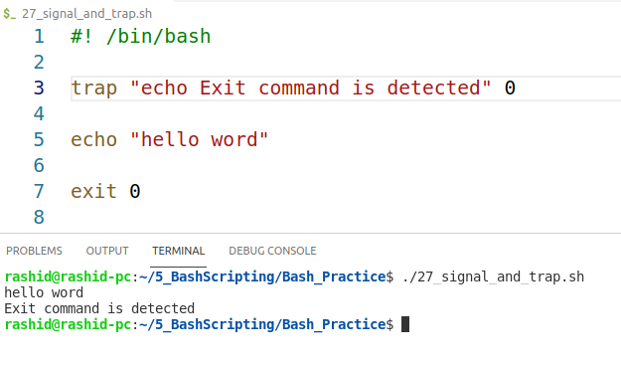
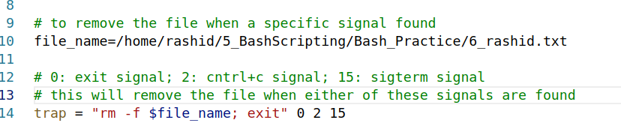
- to see trap that you have defined
- type trap
- to remove trap
  - trap - name_of signal/number_of_signal e.g. trap – 0 2 15

28. Debug a bash script

- bash -x ./script_name.sh OR
- #! /bin/bash -x (in the script) OR
- type set -x (in the script), it will start debugging from the point where you define this
- type set +x (in the script), it will deactivatedebugging from the point where you define this

